**API Results** **Naman Mathur**

**1. DiscoverServices(List<String> services)**

Input: Services are EC2 and S3

Output: JobId

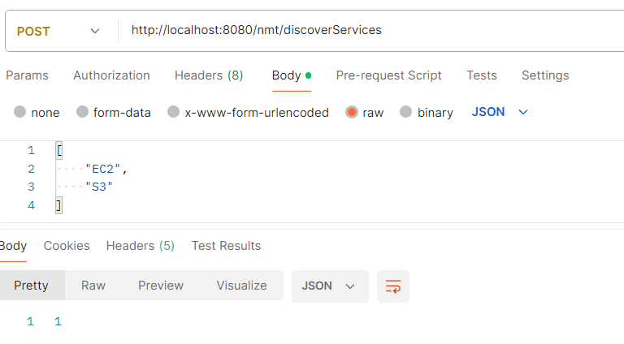

**2. GetJobResult(Jobid)**

Input: JobId

Output: Success or In Progress or Failed

For JobId = 1

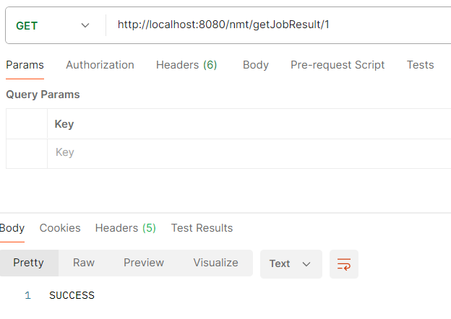

**3. GetDiscoveryResult(String Service)**

Input: Service Name

Output: For S3 - List of S3 Buckets

For EC2 - List of Instance Ids

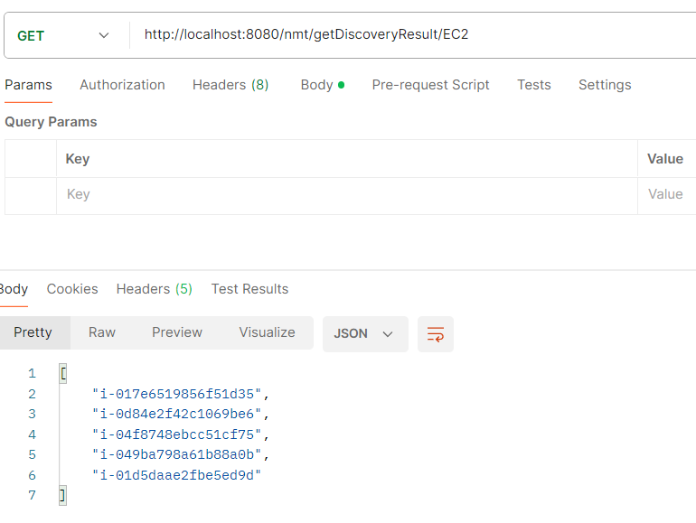

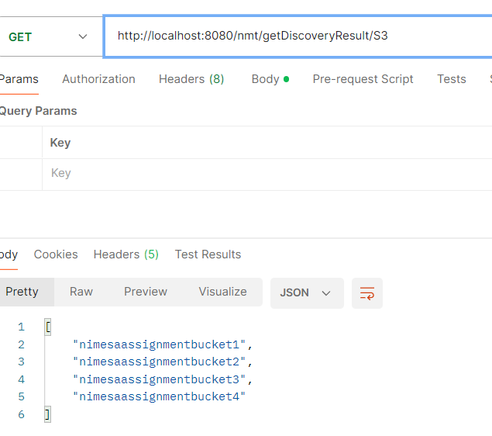

**4. GetS3BucketObjects(String BucketName)**

Input: S3 bucket name

Output: JobId

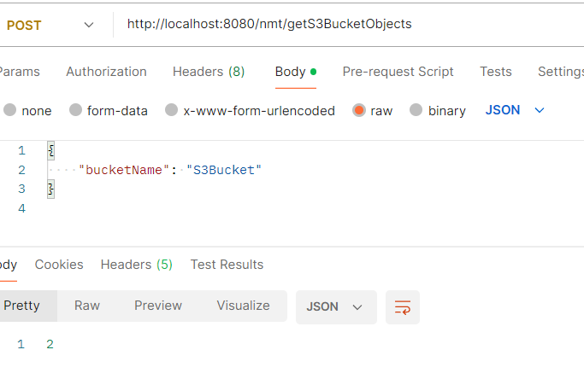

**5. GetS3BucketObjectCount(String BucketName)**

Input: S3 bucket name

Output: Count

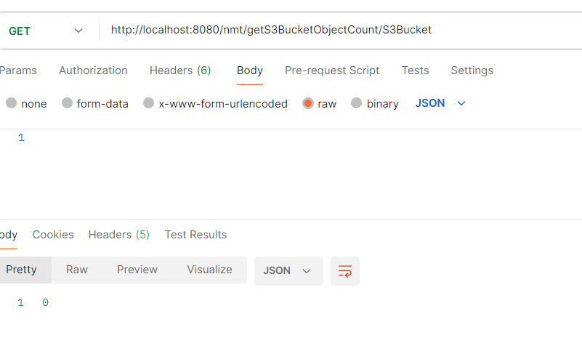

**6. GetS3BucketObjectlike(String BucketName, String Pattern)**

Input: S3 bucket name

Output: List of file names matching the pattern

